Practical - 8

**AIM : Study of Docker swarm and Deployment of ML project in swarm network.**

The objective of this lab is to understand Docker Swarm, a container orchestration tool, and deploy a machine learning project in a Swarm network using three Linux host systems.

**Prerequisites:**

- Three Linux host systems (e.g., Ubuntu)

- Docker installed on each host (follow the installation steps in the previous response)

- Basic understanding of Docker and machine learning concepts

**Lab Setup:**

- Assign unique hostnames and IP addresses to each Linux host.

- Ensure that the hosts can communicate with each other over the network.

**Step 1:** Initialize Docker Swarm

On the first host, initialize Docker Swarm to create a Swarm manager node

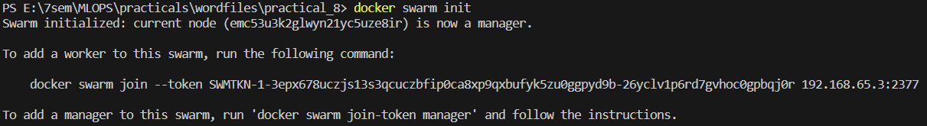

**Step 2:** Join Worker Nodes





**Step 3:** Deploy a ML Model as a Service

Create a Docker Compose file (e.g., `ml_app.yml`) with the following content

version: '3'

services:

ml_app:

image:pr8:tag

ports:

- "8080:8080"

deploy:

replicas: 3

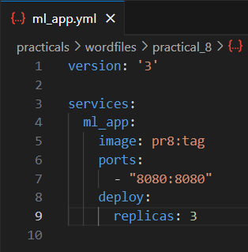

**Step 4:** Deploy the Service

On the manager node, deploy the ML project as a service:

docker stack deploy -c ml_app.yml pr8



**Step 5:** Verify the Deployment

Check the status of the deployed service:

docker service ls

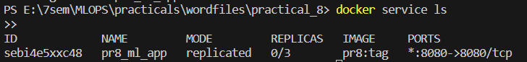

You should see the service running on three replicas.

**Step 6:** Access the ML Project

You can access the ML project on any of the worker nodes using their IP addresses and port 8080 (the port we exposed in the Compose file).

<http://192.168.65.3:8000/>

**Step 7:** Scaling

Experiment with scaling the service up or down to see how Docker Swarm manages the

replicas.

docker service scale pr8_ml_app=5

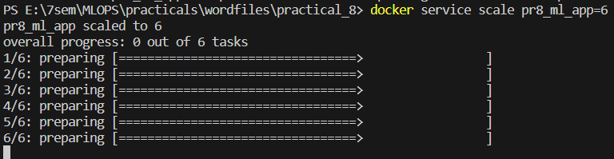

**Step 8:** Removing the Stack

When done, you can remove the stack:

docker stack rm pr8



**Step 9:** Leave Swarm

On worker nodes, leave the Swarm when you're finished:

docker swarm leave --force



**Step 10:** Shut Down

Shut down all host systems.